SOFTWARE TESTING – TUTORIAL 4

Website:SauceDemo https://www.saucedemo.com/?utm_source=chatgpt.com

TC01 – Verify Product Selection
Test Case: Verify product is displayed.
Steps:
- Open SauceDemo website.
- Login with valid details.
- Check the product.
Screenshot: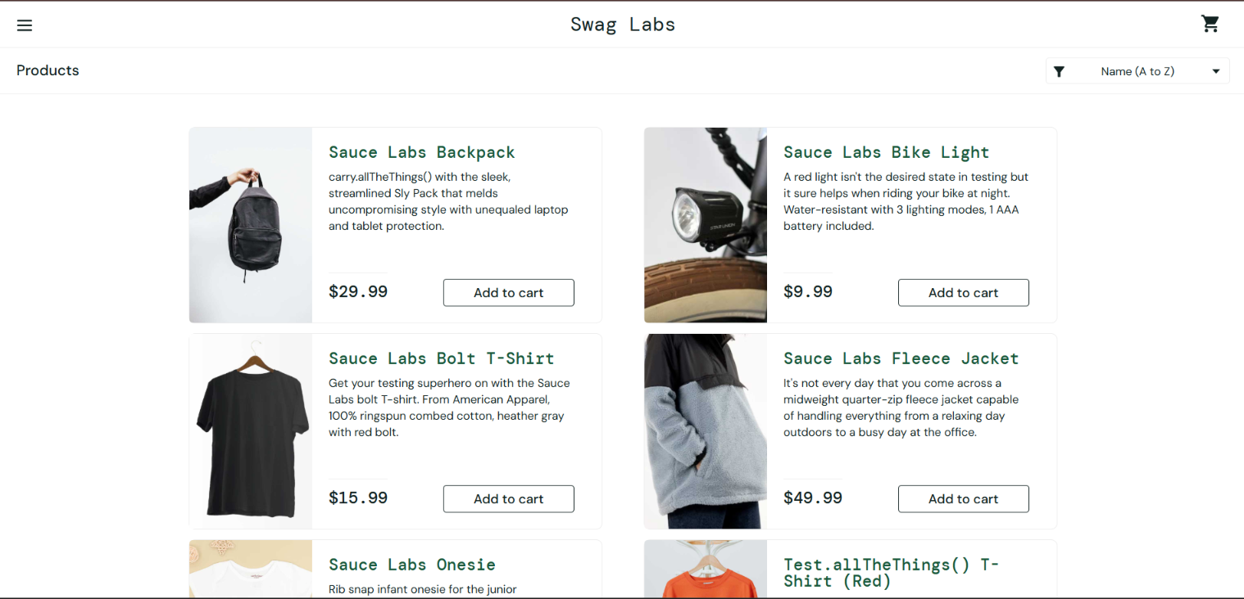
Expected Result: Product should be displayed.
Actual Result: Product displayed successfully.
Status: PASS

TC02 – Verify Product Details
Test Case: Verify product details are displayed.
Test Data: Sauce Labs Backpack
Steps:
- Open SauceDemo.
- Login.
- Click Sauce Labs Backpack.
- Check product details.
Screenshot:
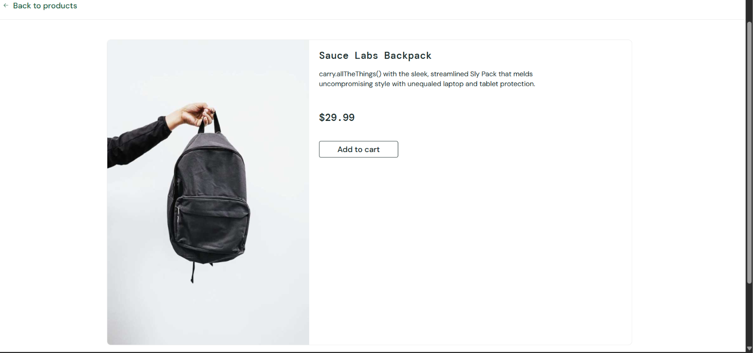
Expected Result: Product details should be displayed.
Actual Result: Product details displayed successfully.
Status: PASS

TC03 – Verify Add to Cart Functionality
Test Case: Verify product can be added to cart.
Steps:
- Open SauceDemo.
- Login with valid details.
- Click Add to cart for Sauce Labs Backpack.
- Open the cart.
Screenshot: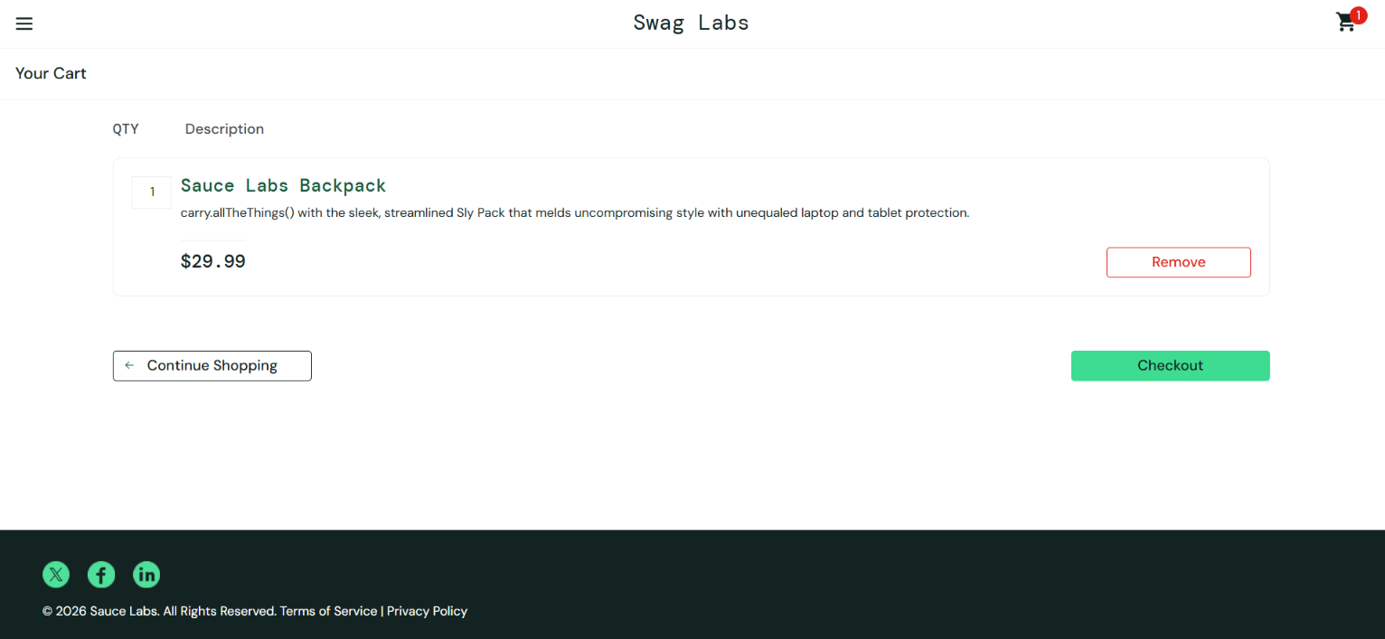
Expected Result: Product should be added to the cart.
Actual Result: Product added successfully.
Status: PASS

TC04 – Verify Checkout with Valid Details
Test Case: Verify checkout with valid details.
Steps:
- Open Cart.
- Click Checkout.
- Enter valid details.
- Click Continue.
Screenshot: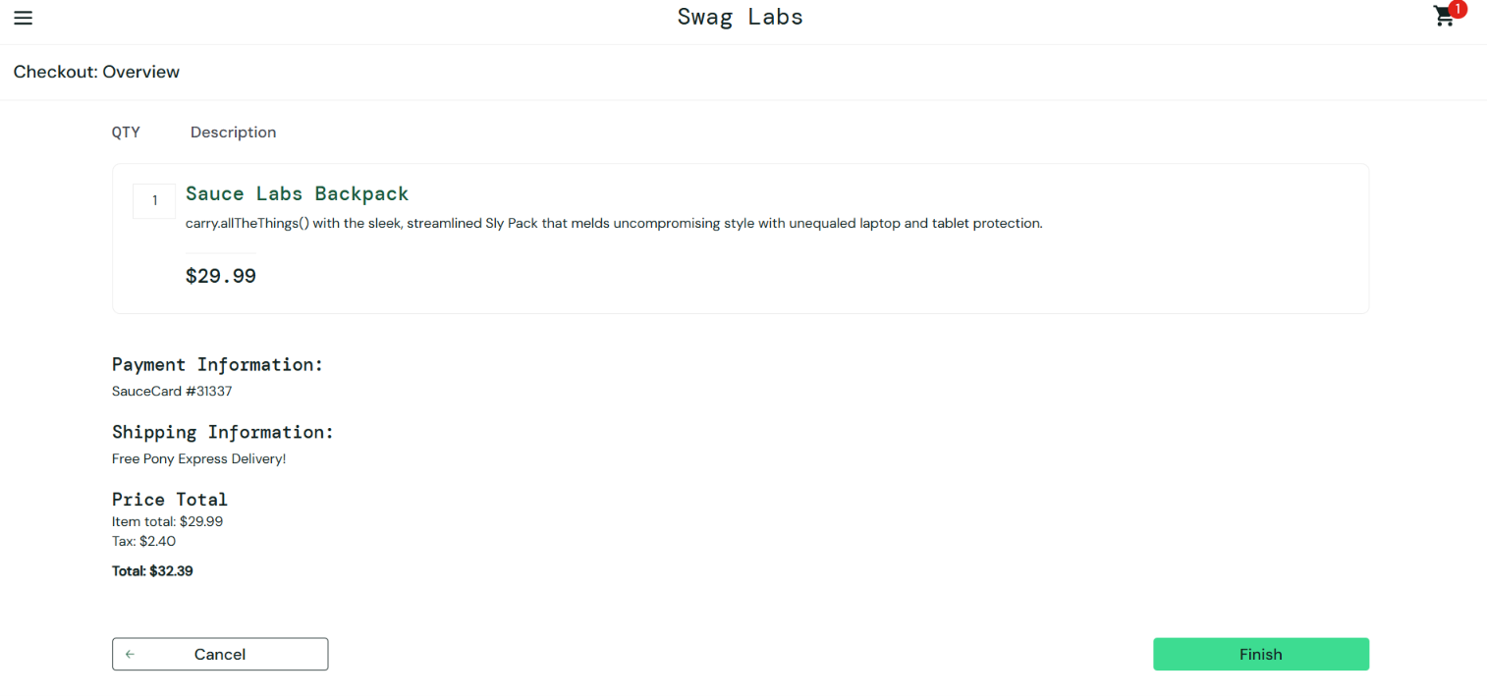
Expected Result: Checkout should proceed successfully.
Actual Result: Checkout proceeded successfully.
Status: PASS

TC05 – Verify Checkout Validation with Blank Details
Test Case: Verify checkout validation when required details are blank.
Steps:
- Open the Cart.
- Click Checkout.
- Leave all details blank.
- Click Continue.
Screenshot: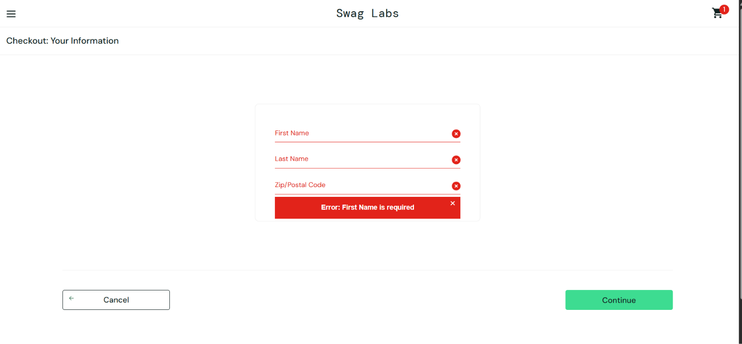
Expected Result: Error message should be displayed.
Actual Result: Error message displayed.
Status: PASS

TC06 – Verify Payment Information is Displayed
Test Case: Verify payment information is displayed during checkout.
Steps:
- Open the Cart.
- Click Checkout.
- Enter valid details.
- Click Continue.
- Check the Payment Information section.
Screenshot: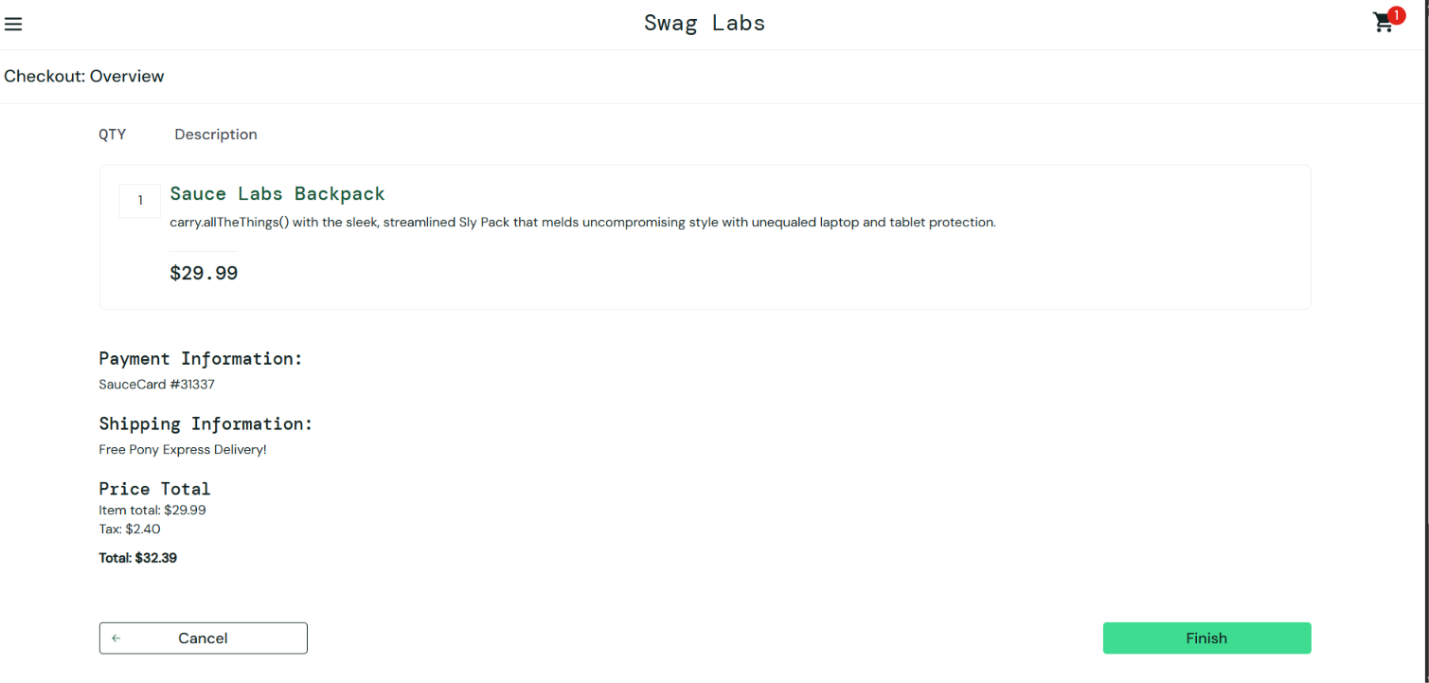
Expected Result: Payment information should be displayed.
Actual Result: Payment information displayed successfully.
Status: PASS

TC07 – Verify Checkout Page Loads Properly
Test Case: Verify checkout page loads properly.
Steps:
- Open the Cart.
- Click Checkout.
- Observe the checkout page.
Screenshot: 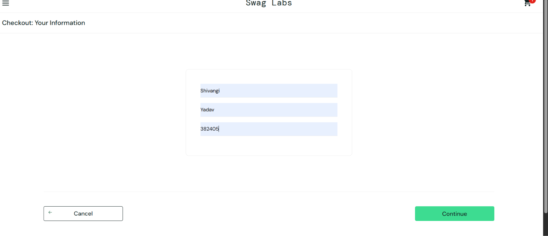
Expected Result: Checkout page should load properly without errors.
Actual Result: Checkout page loaded properly.
Status: PASS

TC08 – Verify Remove Product from Cart
Test Case: Verify product can be removed from cart.
Steps:
- Open SauceDemo.
- Login with valid details.
- Add Sauce Labs Backpack to cart.
- Open the Cart.
- Click Remove.
Screenshot: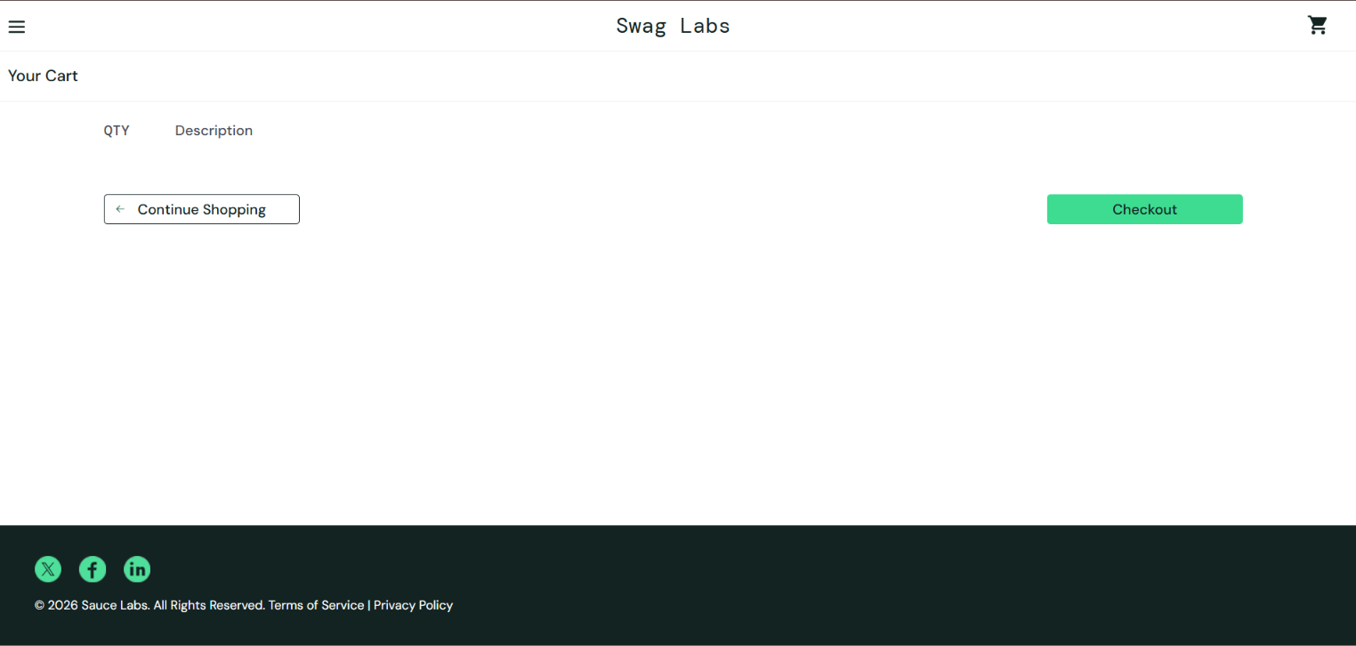
Expected Result: Product should be removed from the cart.
Actual Result: Product removed successfully.
Status: PASS

